No. | Answer
 | V(ethanol) = 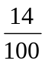 × 700 mL = 98 mL
n(C₁₂H₂₂O₁₁) = 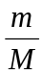 = 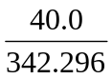 = 0.1169 mol
∴ c(C₁₂H₂₂O₁₁) = 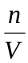 = 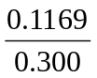 = 0.390 mol L^{–1}
n(of NaCl in original solution) = 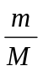 = 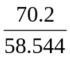 = 1.199 mol = n (of NaCl in dilute solution)
V(dilute NaCl solution) = 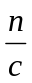 = 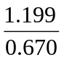 = 1.790 L
∴ (1.790 = 1.00) = 0.790 L of water must be added.
m(NH₃ in dilute solution) = 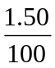 × 250 = 3.75 g = m(NH₃ in concentrated solution)
V(concentrated solution) = 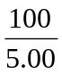 × 3.75 = 75.0 mL
n(Na₂CO₃ in dilute solution) = c × V = 1.08 × 0.0300 = 0.03240
n(Na₂CO₃ in concentrated solution) = 0.03240
m(Na₂CO₃) = n × M = 0.03240 × 105.99 = 3.43 g
m(glucose in 1st solution) = 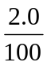 × 50 = 1.00 g
m(glucose in 2nd solution) = 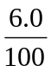 × 50 = 3.00 g
Total mass of glucose in new solution = 1.00 + 3.00 = 4.00 g
c(new solution of glucose) = 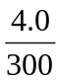 × 100 = 1.3% m/V
600 ppm mercury = 600 g of mercury in 1.00 × 10⁶ g of lake water
1.00 x 10⁶ g = 1.00 Mg
m(Hg) in 5.00 Mg lake water = 5 x 600 = 3.00 × 10³ g
V₂ = 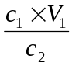 = 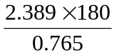 = 562 mL
∴ 382 mL (562 – 180) of water must be added
n(K⁺ in 1 L of solution) = c × V = 0.0097 × 1.00 = 0.0097 mol
m(K⁺ in 1 L solution) = n × M = 0.00970 × 39.10 = 0.379 g
1 L of sea water = 1000 mL of sea water = 1000 g of sea water
∴ there is 0.379 g of K⁺ in 1.00 × 10³ g of sea water
∴ 0.379 × 1 × 10³ = 379 g of K⁺ in 10⁶ g of sea water = 380 ppm
c(initial solution of Z) = 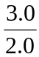= 1.50 g L^{–1}
m(Z in 2.0 mL of this solution) = 1.50 × 0.0020 = 0.00300 g
= m(Z in 5.0 L of dilute solution)
c(dilute solution of Z) = 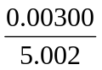= 6.00 × 10^{–4} g L^{–1}
m(Z in 1.0 μL = 1 × 10^{–6} L of this solution) = 6.00 × 10^{–4} × 1 × 10^{–6} = 6.0 × 10^{–10} g

